Git and Github Tutorial:

1. Setup Git user name and email in Git bash to associate Git with Github

$ git config –global user.name “DataEngineer”

$git config –global user.email “[arpitsinha.it23@gmail.com](mailto:arpitsinha.it23@gmail.com)”

To view this:

$ git config –global –list

When we create a folder and put one file in local system at that point it is just a normal folder and file (working directory)

Now to convert a working directory to Git Repository, we need to create a .git folder in that same location.

Right Click , choose open git bash here in the same location.

**Type command :**

1. git init

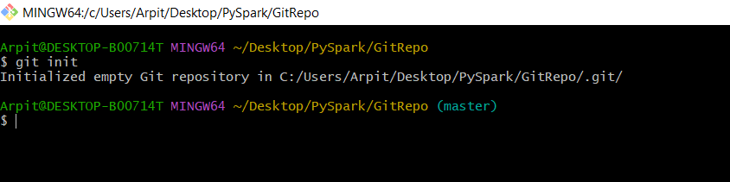

With this now working directory in converted into Git repository. And Git will now continue to store and track all its internal info within .git folder

1. **git status**

**$ git status** ( This provides the current status of the git repository )

1. **git add**

**$ git add <filename>** ( It saves/add all untracked files from working directory to stage directory )

**$ git add \*** (if there are multiple untracked files that needed to be added in stage directory )

**$ git add .** ( this is recommended because it tracked changed, deleted all types of files, directories )

1. **git commit**

$ git commit –m “first commit” ( This permanently saves all the staged files/folders to the git repository )